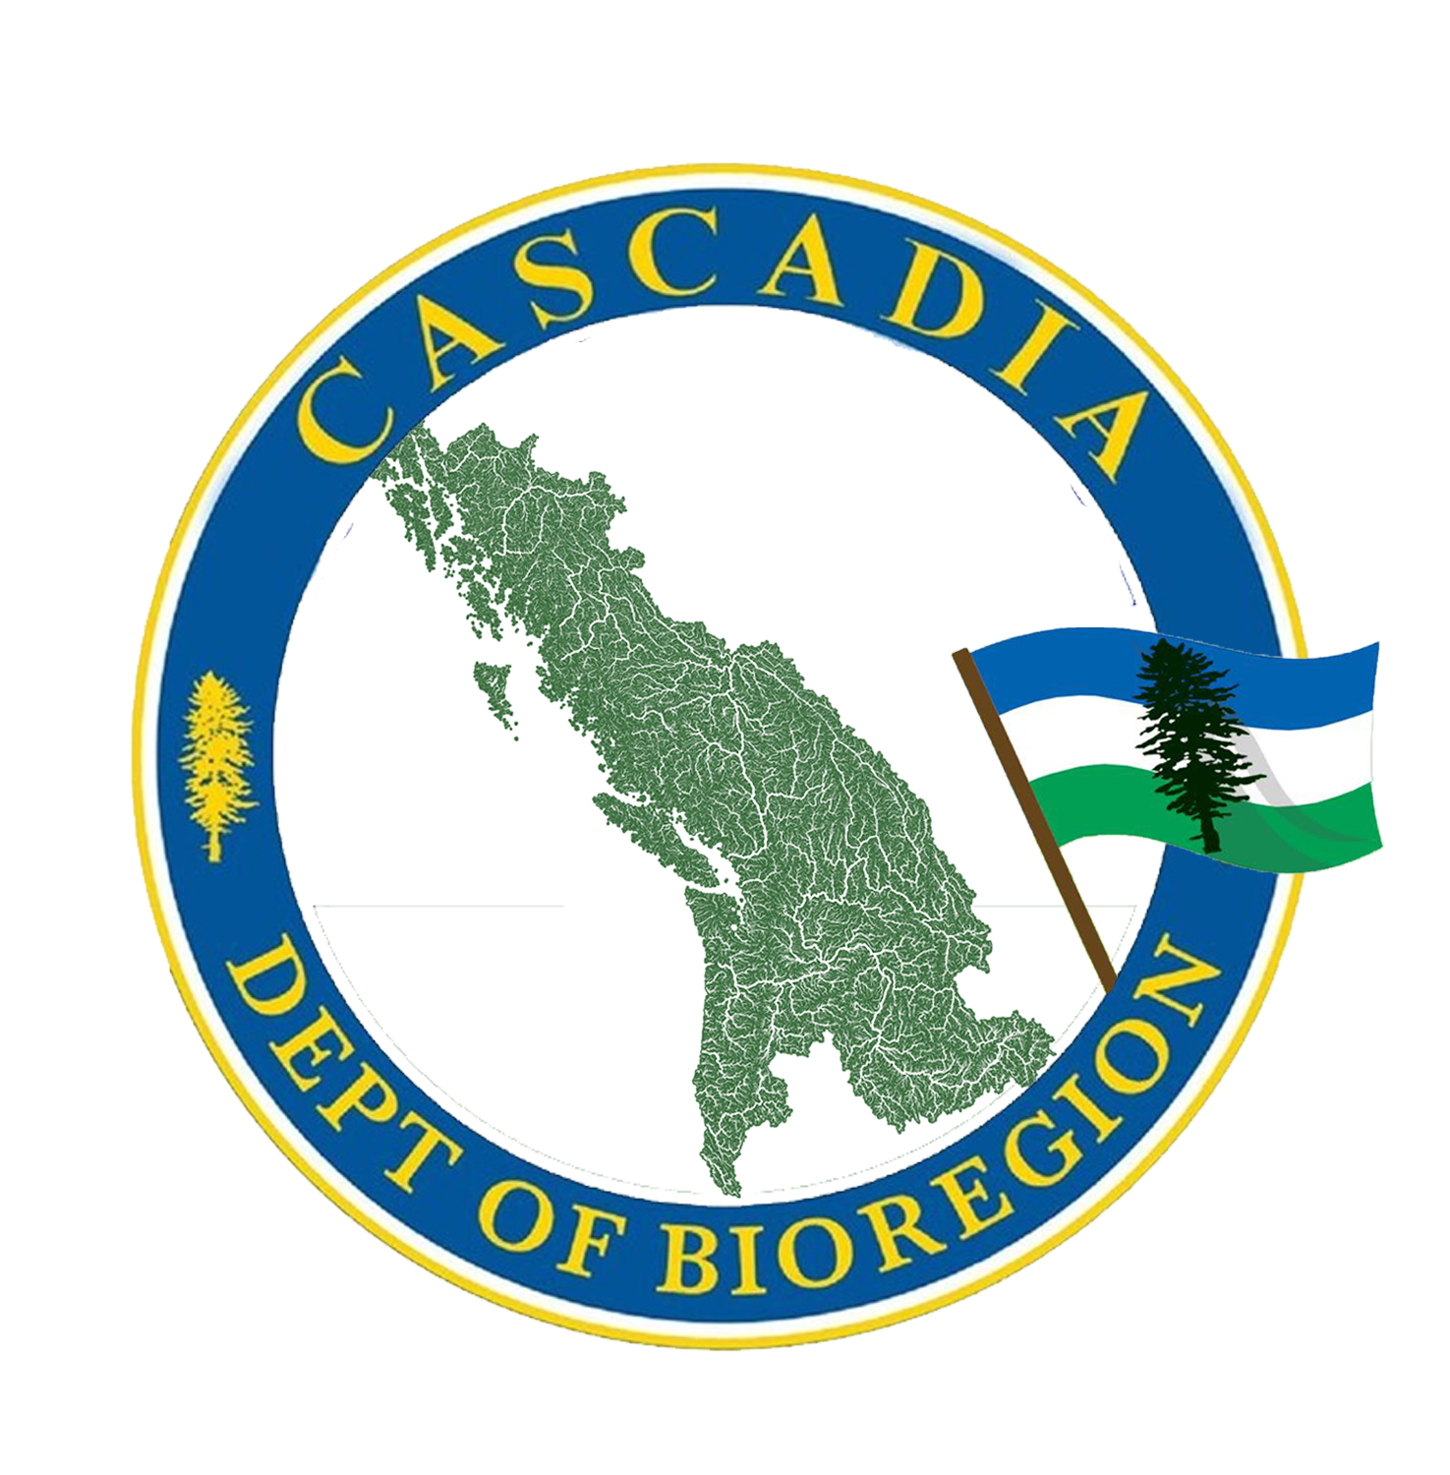

Bioregional Awareness Quiz
https://cascadiabioregion.org/bioregional-quiz

Take the quiz!
This quiz provides a lot of starting points for getting to know your own living home region.
It can be sobering to realize how little we know right now. The intention of the quiz is not to make us feel bad about how disconnected we are, but instead to gain awareness of the multi-layered things yet to discover about the richness of our home place.

Please treat it as an opportunity. Maybe you want to only choose a few questions, the ones that call to you the most. Feel free to find out the answers in any way you can: Ask your neighbors, go to the library, read the newspaper with this sort of focus, go outside, wander around, and pay attention every day. “Waste time” doing nothing but noticing our world.

The goal of this booklet is simple, to help people better connect with where they live, plug in a deeper and more authentic way, and begin to build alternatives for a more livable and healthy planet. There’s no way to cheat. Spend some time investigating; ask for some help. And feel free to make up some more questions of your own.

How many of the questions can you answer, without referring to the internet or field guides first?

Welcome home!
Bioregionalism is a call to become knowledgeable residents and guardians of the places where we live. Although we are seldom aware of it, we live in naturally unique physical, ecological, historical, and cultural areas whose boundaries are more often ridgetops than county lines and state borders.
This is a call to get to know our local land and water; our local weather and sky; our local plants and animals; our local neighbors and communities. It is a call to join our hearts, hands, and minds with what has been, what is, and what could be, in this place.

Getting to know the place where we live is important for both our well-being and the well-being of our home. Becoming aware of our “sense of place” helps us to see it as a unique part of the living earth, deserving of respect, gratitude, and careful treatment. We, humans, can then begin to shift how we live more towards balance and harmony with the wider life community. Security begins by acting responsibly at home.

Making Connections
- Where does the water in your house come from? Trace the water you drink from rainfall to the tap. Where did the cloud gather its moisture?
- Where does the water go that drains from your sink? What about the water (& other stuff) leaving your toilet? How is it filtered?
- How many watersheds exist in your county or city? Can you name them?
- Choose a favorite meal and trace the ingredients back through the store…the processing plant…all the way to the soil. How many people, states, or even countries helped produce this meal? What went into the packaging and transportation of its ingredients? How many of the ingredients could you (did you?) get locally or even grow yourself?
- What kind of energy do you primarily use? Where does it come from? Trace the path of energy that powers your home from its sources to you.
- When your garbage is thrown away, where does it go? Does it go to a landfill, or is it sent somewhere else? How about your recycling?
- What are the primary sources of pollution in your area?
- What are the major natural sounds you are aware of in a particular season?
- What are the major human-made sounds you are aware of outside your home?
- What agencies are responsible for planning future transportation and land use in this area?
- List three critical environmental issues in your area. What can you do to help?
- Draw a map of your territory and the areas you travel to regularly – without using human markers like buildings or street names.
- If you look out your window, how many different types of trees, birds, or bushes can you see? How many can you name?

Earth
- What primary geological events or processes shaped the land where you live? (Extra Points: What is the evidence?)
- When was the last time there was a major geologic event that happened near you? How did it change the area, and how did recovery happen?
- What soil series are you standing on?
- What types of food are grown near you? What is your favorite food that grows locally? What time of year is the best time to plant it, and when is the best time to harvest it?
- How has the land in your area been used or transformed by humans, over the last two centuries?
- Who lived here prior to European settlement, and what were their primary subsistence techniques?
- What was the vegetation type in this area prior to settler colonization?
- Where is there wilderness in your bioregion?

Water
- What is the elevation above sea level where you live?
- What is the average annual rainfall for your area? What was the total rainfall in your area last year?
- What kinds of runoff go into your nearest body of water?
- Is it safe to swim in your closest body of water?

Neighbors
- What Spring wildflower is consistently among the first to bloom where you live?
- Name seven common trees in your area. Which ones are native? For the others, how did they get here? Why were they brought?
- What types of forests are near you? What trees grow the fastest, what does an intermediary forest look like, and how about a mature old-growth forest?
- Which indigenous people inhabit(ed) your region before you? Are they still here? What languages did they speak? Where is, or was the nearest First Nation settlement closest to you? What is its name?
- 21b. What are/were the First Nations’ names for the place you live or elements of this place (such as nearby mountains and rivers – are there any stories associated with the names)?
- What were the primary subsistence techniques of the culture that lived in your area before you?
- Name five edible wild plants in your region and their season(s) of availability.
- Name three medicinal wild plants in your region, and what they can be used for. BONUS: which parts are the most effective (stems, roots, fruits…)?
- Name seven mammals common to your area. Which are native and which are new here? From where did they come? Which animals are extinct in your area?
- Name ten birds common to your area. (Extra Points: Which are year-round residents? Which are migratory?) (For the EXPERT: Where do the latter winter over?)
- Name five types of grass in your area. Are any of them native?
- Name four wild mushrooms that grow in your area, two edible (only if you are an expert) and two poisonous.
- Describe the defense techniques used by three different animals, plants, or marine lines living in your area. (Examples: camouflage, poison, thick skin, thorns…)
- What are the major plant associations in your region?
- What plant or animals are the “barometer” of environmental health for your bioregion? How is it doing?

Sky
- Sitting in your living room, point North.
- How recently was the Moon full? What phase is it in now?
- On what day of the year are the shadows the shortest where you live?
- From what direction do winter storms or trade winds come in your region?
- How long is the growing season where you live?
- How has the typical weather changed in your area since you were born? (Ask an older person to remember weird weather.)
- Name one constellation or star that comes out only in winter and one that comes out in summer.

Fire
- When was the last time a fire burned in your area?
- What caused it?
- How did the land change after that? What grew back first, second, or third? What bugs, birds, and animals followed?
- How is fire dealt with where you live? (Controlled burns, completely prevented, seasonal controls – what sort?)
- How do fires affect air quality? What are the responsible types of practices we can take to help prevent forest fires?

This version of “Where you at?” - A Bioregional Quiz has been edited, updated, and published by Brandon Letsinger and the Department of Bioregion, a 501(c)3 nonprofit.
https://cascadiabioregion.org

These questions began with “Where You At – A Bioregional Quiz” by Leonard Charles, Jim Dodge, Lynn Milliman, and Victoria Stockley, which was first published in the Winter 1981 issue of Coevolution Quarterly and subsequently reprinted in Home! A Bioregional Reader (New Society Publishers, ISBN 0-86571-188-7, 1990).

In addition, a few of the questions were gleaned years ago from the work of Fox Tales, Chas Clifton, & the folks at the Co-Intelligence Institute.

Tina Fields made extensive further additions and when it grew unwieldy, created the breakdown by category to organize the expanding inquiry. https://indigenize.wordpress.com/2013/03/21/bioregional-quiz/

